My Frog Pond

I had the urge to create a water feature with a fouintain or spring that I could hear from my deck. I decided on a fish pond. I looked up the basic designs and decided on the simplest and cheapest.
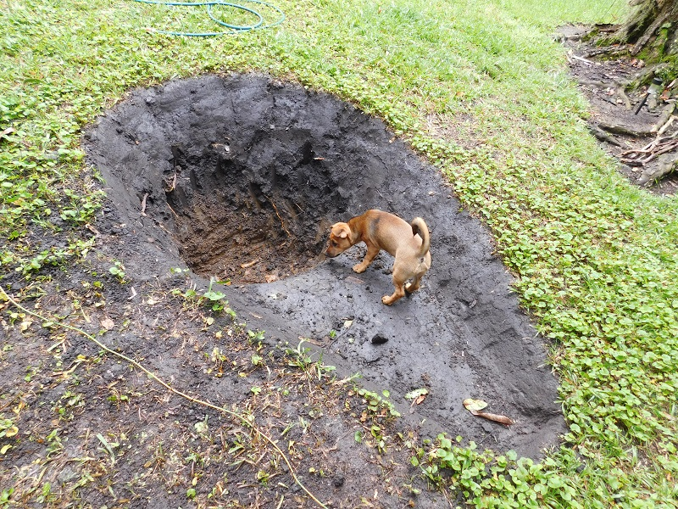
I never got around to stocking it with fish. The frogs had moved in, and along with them, a fishing spider. I was happy – sitting outside on the deck or lying in bed listening to the frog songs.

Before very long I had a pond full of tadpoles and soon had a chorus of raucous toads. The fishing spider kept the mosquito larvae in check and had a main course of tadpoles.
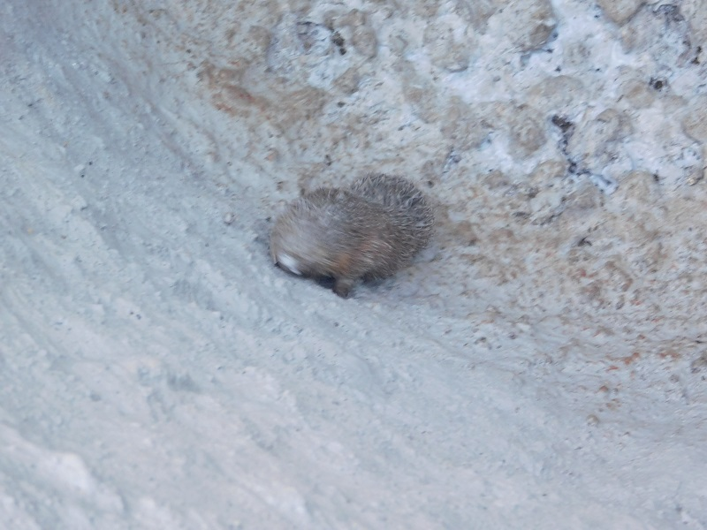
The fishing spider places its front legs on the water surface and waits for movement, then quickly swims out to catch its meal. Somehow it seems to avoid being caught by the frogs.

I installed a small submersible pump to keep the water moving, and this provided enough relaxing sound of moving water.
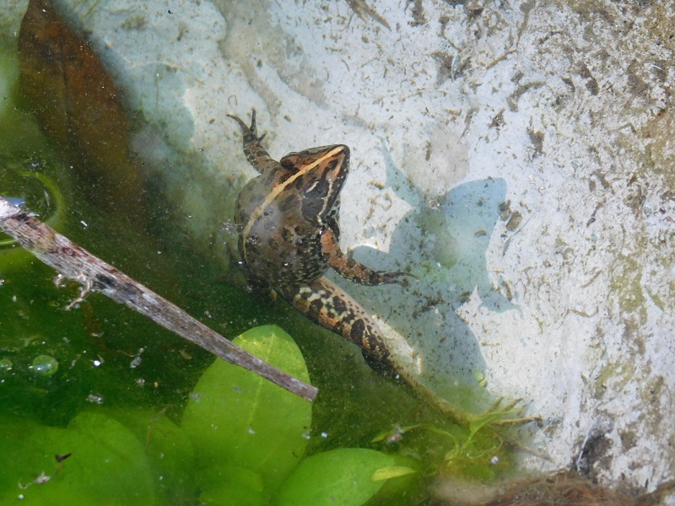
The only problem is that Night Adders love frog dinner and they catch the odd one. One of my dogs hates them because she’s been bitten twice already. She does not learn from this – she wants revenge! Fortunately the night adder is not much more toxic than a bee, and she cannot swallow the snake.

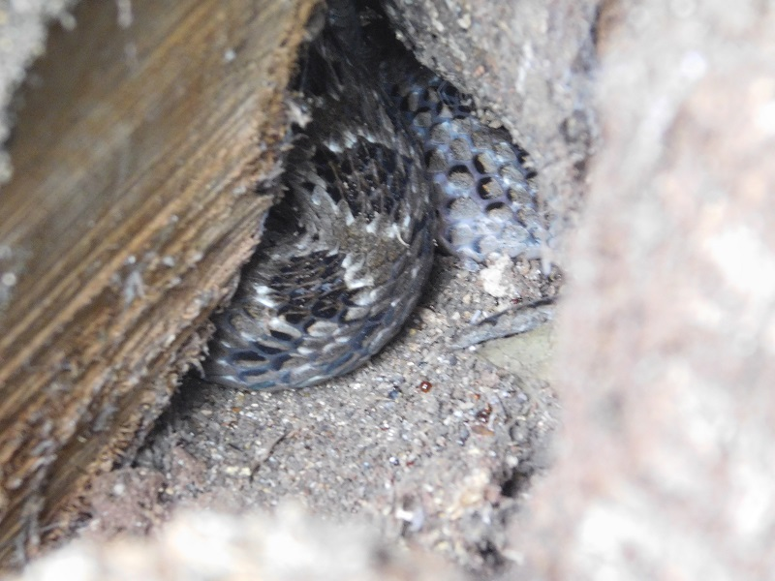
When she foams at the mouth I know that she has tried to catch a frog or toad. I have never tried any of the remedies, such as feeding her black coffee, but I hope that after a few foaming mouths she will learn to leave the frogs alone. At least she has stopped pestering the local night adder!

And here is the home of our resident night adder!

